List of Speakers
(By order of appearance)

Mr Patrick Deboyser – Professor at the European College of Parma, Italy

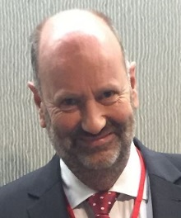
Patrick Deboyser has been for 34 years an official of the European Commission, where he has held a series of managerial positions such as Head of Pharmaceutical, Head of Cosmetics and Head of Food law and Biotechnology. He has also served for more than ten years as Minister-Counsellor at the EU Delegation to Thailand, representing the EU interest in Thailand and South-East Asia in the areas of public health, trade, development, agriculture, and food safety.
After retiring from the European Commission in 2018, Mr. Deboyser has maintained a residence in Thailand where he has been working mainly on EU-funded programs in the areas of public health, agriculture, fisheries and organic farming. Mr. Deboyser also has considerable academic experience, having lectured on EU law in the 90’s at the University of Brussels and the University of Louvain; since 2003, he is a Professor at the European College of Parma.

Ms Milada Sycova – Head of National Reference Centre and Laboratory for Food Contact Materials, Slovakia
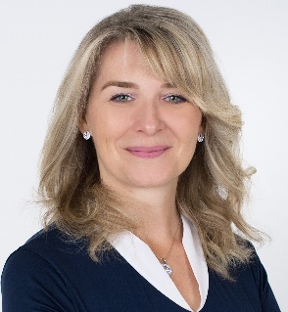
Milada Sycova is the Head of National Reference Centre and Laboratory for food contact materials, Public Health Authority in Slovakia where she has 23 years of experience. She is nominated by The Ministry of Health of Slovak republic as a national expert for food contact materials in following European institutions: DG SANTE, Council of Europe, EFSA and EURL - Joint Research Centre. She has an extensive trainer experience as she was greatly involved in the BTSF and TAIEX programs since 2012 as a tutor on Food Contact Materials rules and Controls (including delivery of lectures and moderation of exercises) and TAIEX expert. She is responsible for preparation of legislation on food contact materials and since 2023 also for materials intended to come into contact with drinking water. She is responsible for organisation and coordination of official controls.

Ms Jitka Sosnovcova – Head of National Reference Laboratory for Food Contact Materials and Articles, National Institute of Public Health, Czech Republic
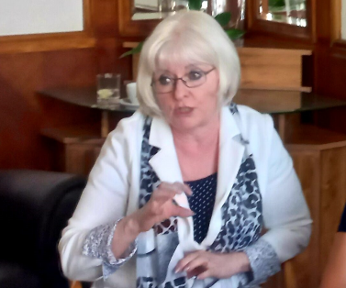
Ms. Jitka Sosnovcová has been involved in food contact materials (FCM) for more than 35 years. Jitka graduated from the University for Chemistry and Technology in Prague with Master of Science in Physical and Analytical Chemistry in 1983. She has an extensive background in food safety, protection of consumer health and risk assessment of exposure to chemicals. In 2008 Jitka was appointed as Deputy Director for Laboratory Activities and in 2009 she became the General Director of the Institute, a position she held until 2018. She was then appointed as Crisis Manager of the Institute. Throughout her career and for more than 35 years, Jitka has served as the Head of the NRL for FCM, working with the Ministry of Health. Since 2004 Ms. Sosnovcová has represented the Czech Republic in various expert working groups of the European Commission. She is a member of working groups on FCN and on toys safety. She is also a member of the EFSA FCM Network, the Committee of the Council of Europe for FCM and as head of the NRL is a member of the European network of FCM NRLs led by EURL FCM.

Mr Eric Barthelemy – Senior Scientific Officer for Food Contact materials, European Food Safety Authority

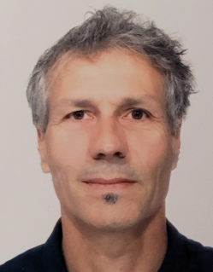
Eric Barthélémy has been working in the safety assessment of Food Contact Material (FCM) since 2002. He firstly joined the French Food Safety Agency (ANSES) to co-ordinate the Scientific Committee on FCM before moving to the European Food Safety Authority (EFSA) in 2007. Overall, he has co-ordinated safety assessment of substances used to manufacture plastics and active and intelligent materials, recycling processes and treatments such as surface cleaning and ionisation. He has contributed to the elaboration of related guidelines. Since 2014, he is also coordinating the EFSA Scientific Network on FCM to facilitate scientific cooperation and to support harmonisation of risk assessment practices between EU Member States themselves and EFSA.

Mr Bastiaan Schupp – Team Leader – Food Contact Materials, European Commission, DG SANTE
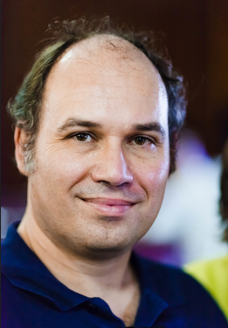
Bastiaan Schupp has worked since mid-2011 on food contact materials in DG Health and Food Safety of the European Commission. As team leader, his main responsibly is the implementation of the specific measures on food contact materials presently in force, particularly on plastic and recycled plastic food contact materials, as well as the revision of Regulation (EC) No 1935/2004. Bastiaan is educated as a chemical engineer and has a background in risk management.

